**Student Name: Weight: Contributes to 10% Engagement Mark**

**Student ID:** **Marks:** **Pass/Fail/Award**

# Group Exercise: Selecting and Sorting Data

## Equipment and Materials

For this lab, you will need:

* A Windows computer with a minimum of 16GB RAM and 250GB of free disk space, capable of nested virtualization
* Access to ORACLE SQL*PLUS.
* The following data provided on Brightspace:
* JustLeeDatabase.zip

## Instructions

1. First, work through steps 2-4 individually. Then arrange a time to come together with your small group. As a group, create one solution based on the best individual solutions for each problem. Further refine the solution as a group as needed.
2. Review the JustLee Bookstore database and physical model.
3. Review the Problem Set, Tips for Success, and Marking Criteria sections of this document.
4. Write a single script that answers all the questions in the problem set.
5. Only one submission is required per group. The submission should include:
   1. A single script file
   2. A spool file showing all results
   3. An attribution list that outlines the activities, time spent and resources associated with completing this assignment. An example attribution list is provided on Brightspace in Course Resources.

## Problem Set

1. Find all books in the computer category with a retail price less than $30. Also include any books published after 31-Dec-05. Sort chronologically by date published.

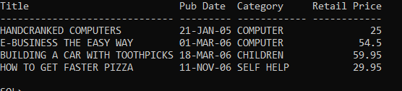

1. Find all orders that have not been shipped. Sort by customer# and then order#.

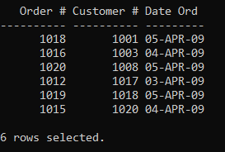

1. Find all orders shipped between April 1, 2009 and April 3, 2009 (inclusive). Don’t include orders shipped to Washington State (WA). Sort by ship date.

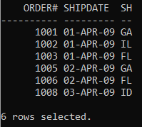

1. Find all books with a publisher ID (pubid) of 2, 3 or 4. Also include all books with a retail price less than $30. Sort by book title (alphabetically).

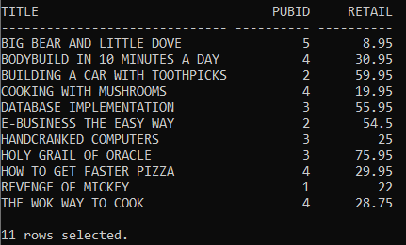

1. Find all customers who have the following characteristics and then sort by customer#.
   1. Were referred by Leila Smith (customer# 1003)
   2. Have a P.O. Box in their address
   3. Have an email domain name of 'axe.com'

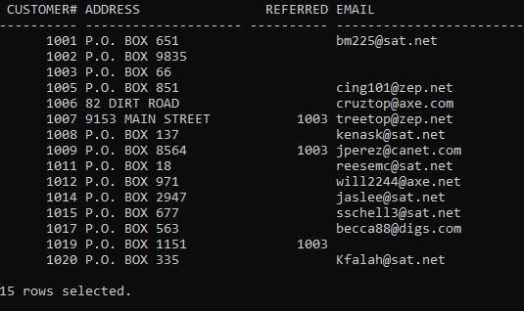

## Tips for Success

1. Use column aliases to create appropriate column headers.
2. Use **set linesize xxx,** in which xxx is a number to set the width of the output.

## Marking Criteria

You must pass all categories to pass the activity.

|  |  |  |  |
| --- | --- | --- | --- |
| **Categories** | **Fail** | **Pass** | **Score** |
| Submission provided | No | Yes | **Pass/Fail** |
| Attribution list provided | No | Yes | **Pass/Fail** |
| Reasonable attempt to solve each question | No | Yes | **Pass/Fail** |
| Spool file with commands included | No | Yes | **Pass/Fail** |
| **Pass/Fail** | | | |